**Exercise - Create, access and manipulate variables**

In this exercise, you will create a flow that prompts users to enter information about new clients and then register them into an Excel file.

1. Launch Power Automate for desktop and create a new flow named **Client registration**.

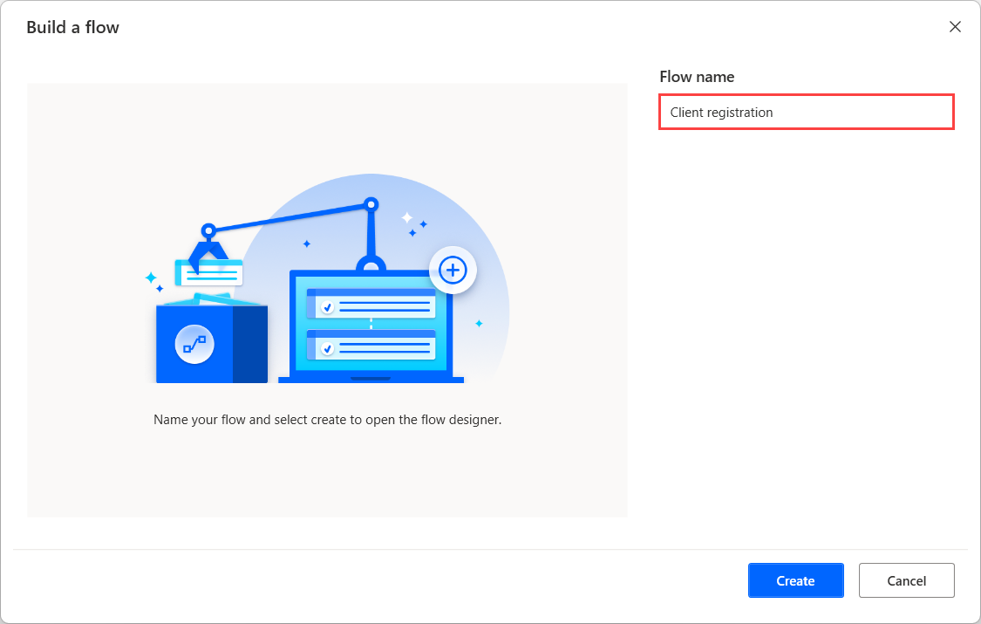

1. Deploy a **Display input dialog** action and populate the **Input dialog message** field with a message asking for the client's name.

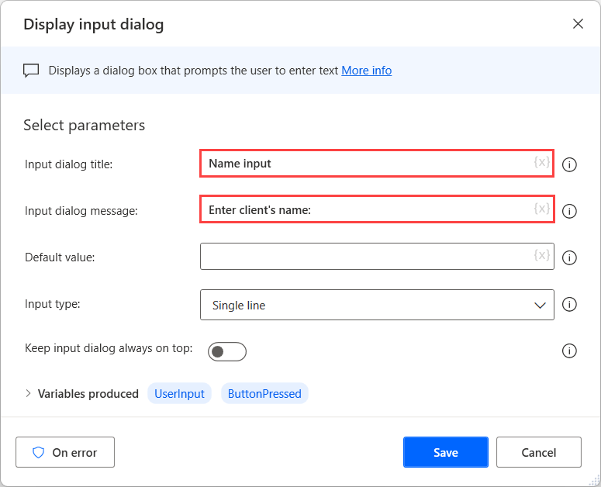

1. Rename the **UserInput** produced variable to a more descriptive name, such as **NameInput**. Then *Save* the action.

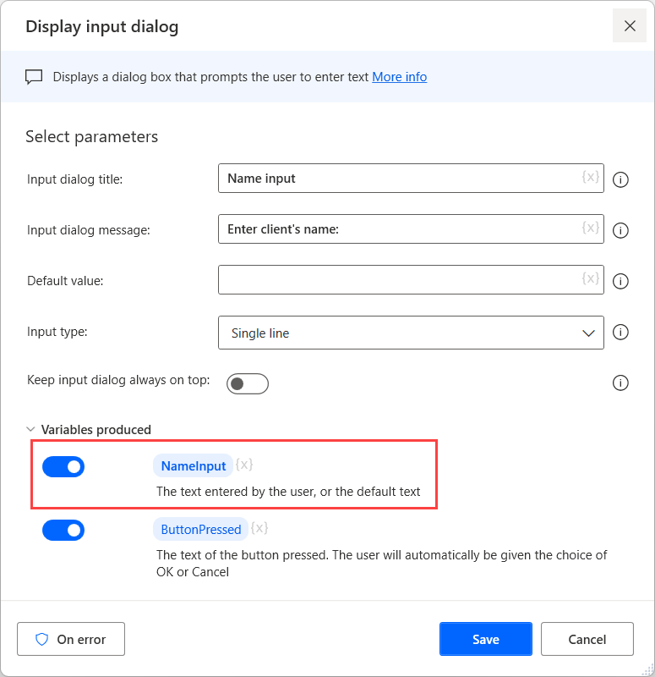

1. Repeat the last two steps 3 more times for the last name, the phone number, and the country code, respectively.

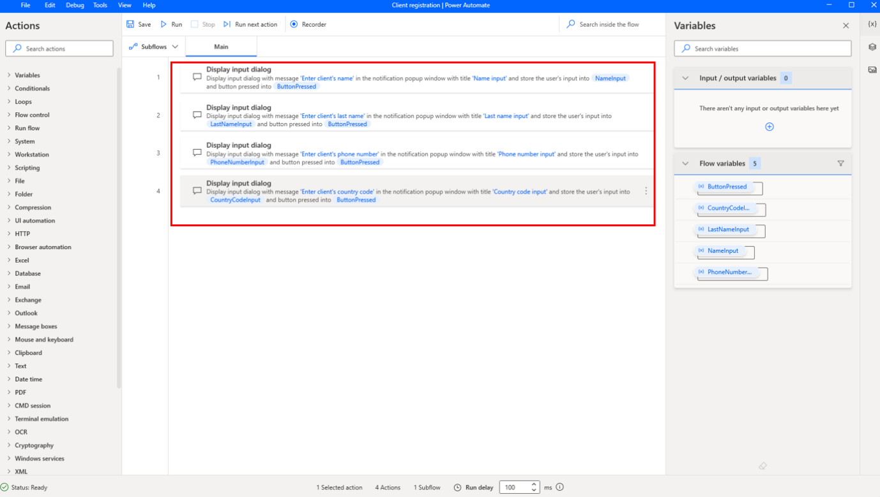

1. Add a **Set variable** action in the workspace to join the name and the last name into a new variable called **FullName**.

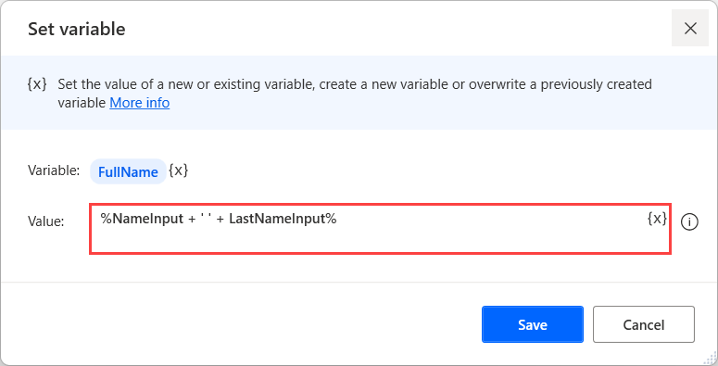

1. Repeat the fifth step to join the country code and the phone number into a variable called **FullPhoneNumber**.

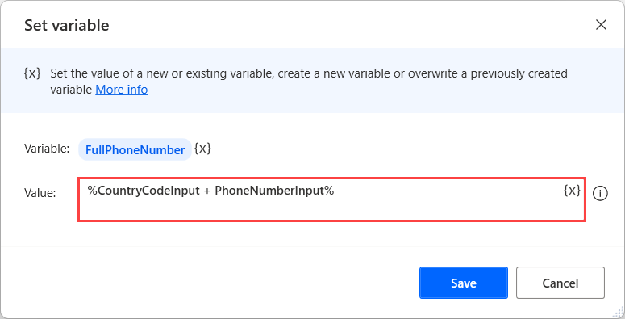

Because both variables have been created through a **Display input dialog** action, they are texts and not numbers. If the variables were numbers, the action above would have performed addition and not string concatenation.

1. Add a **Launch Excel** action to open the Excel file containing the clients' information.

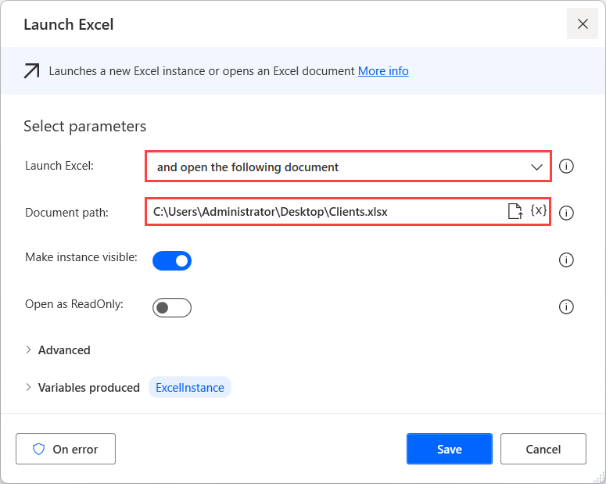

The file must contain two columns, one for the clients' full name and one for the phone number.

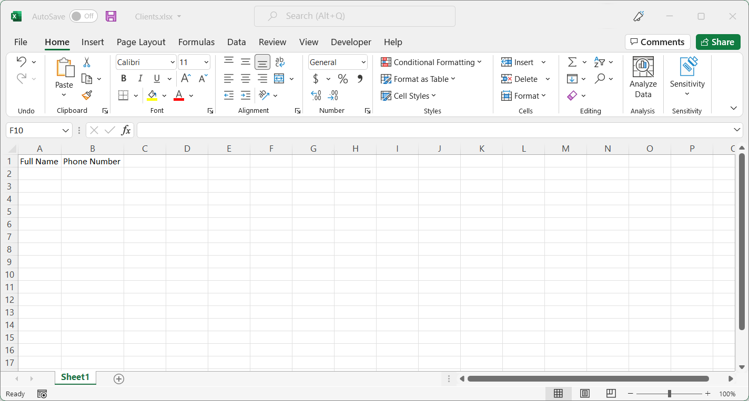

1. Use the created Excel instance as an input for a **Get first free column/row from Excel worksheet** action.

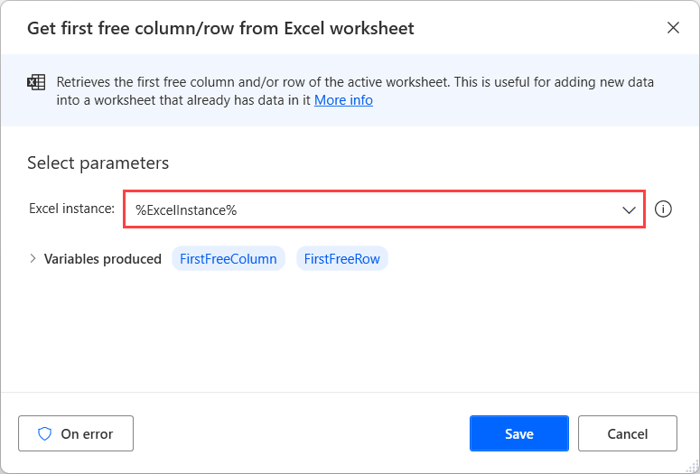

1. Deploy a **Write to Excel worksheet** action and populate the fields with the following values:
   * The **Excel instance** field with the respective Excel instance variable.
   * The **Value to write** field with the **FullName** variable.
   * The **Column** field with the value **1**.
   * The **Row** field with the **FirstFreeRow** variable.

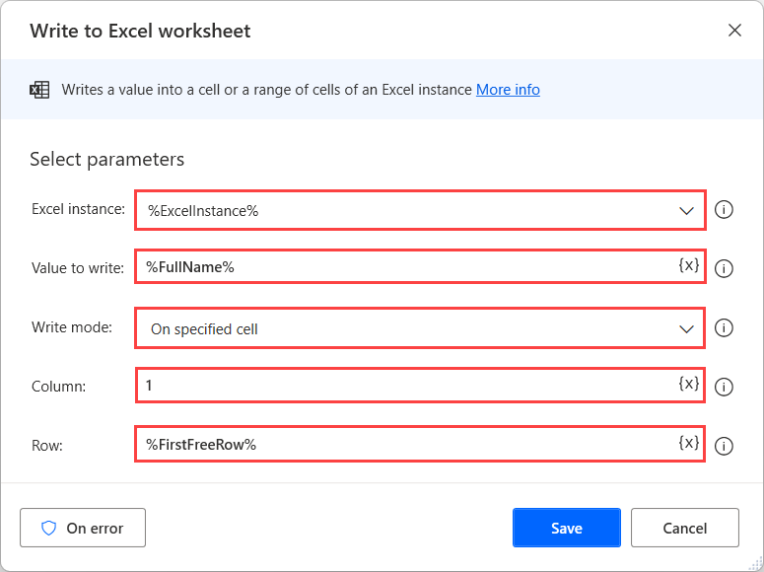

1. Repeat the previous step, populating the **Value to write** field with the **FullPhoneNumber** variable and the **Column** field with the value **2**.

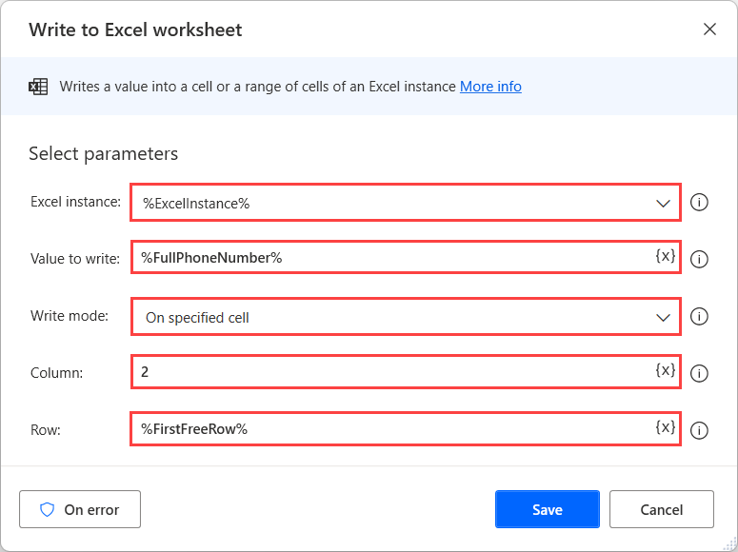

1. Lastly, add a **Close Excel** action to save and close the launched Excel worksheet.

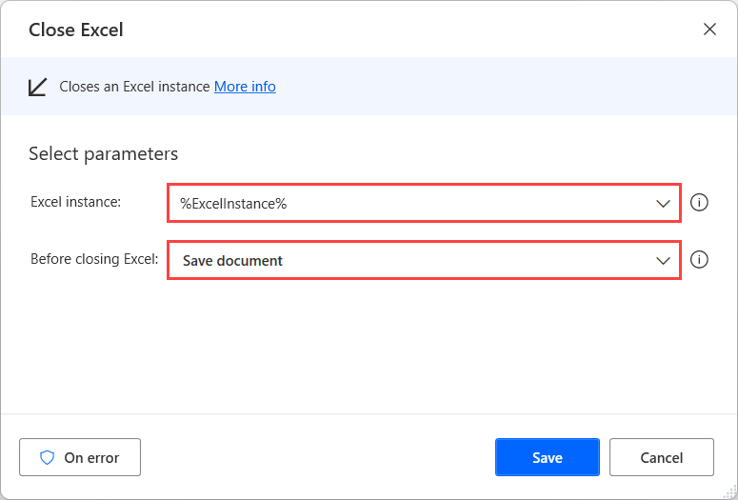

1. Now, the flow should resemble the image below. To check that runs as expected, ensure that your Excel worksheet is closed, and then select the **Run** button in your flow. As you run the flow, you should see the input popups appear on your screen. Continue inputting the information. Once the flow is done you can open the worksheet to ensure that the data was properly recorded.

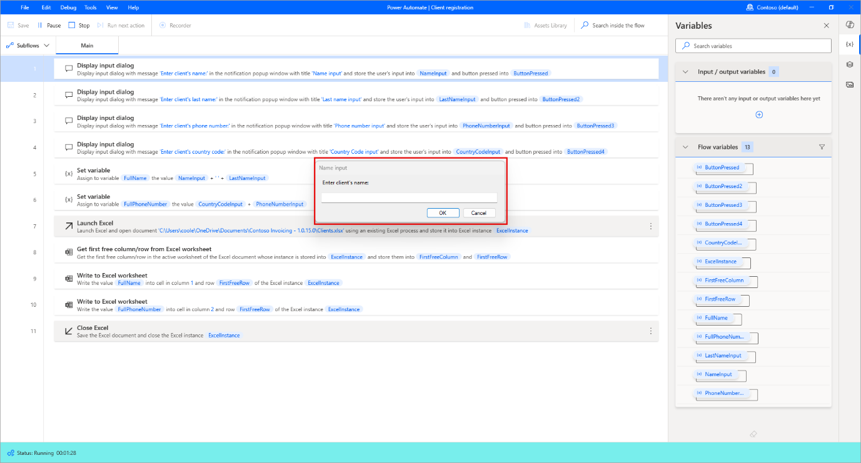

Congratulations! You know how to use variables in a Power Automate desktop flow!